COMPANY MASTHEAD

Dear Patient,
Breast cancer is the most common cancer in women. To treat it, you must find it. If you find it early, you have a greater chance of an accurate diagnosis and effective treatment plan.
For years, the gold standard in breast cancer screening has been 2D mammography. Unfortunately, it doesn’t always deliver clear results. Traditional 2D mammograms suffer from decreasing sensitivity as the density of a woman’s breast tissue increases, or when breast tissue overlaps. This can result in unclear images that leave health providers unsure of what they see, and can lead to cancers being missed.
{NAME OF HOSPITAL OR HEALTH CARE FACILITY} now offers MAMMOMAT Revelation with wide-angle breast tomosynthesis. It’s state-of-the-art 3D mammogram technology that is proven to detect breast cancer better than traditional 2D mammography alone. We’re using it in our practice to give our patients new confidence in their breast health.

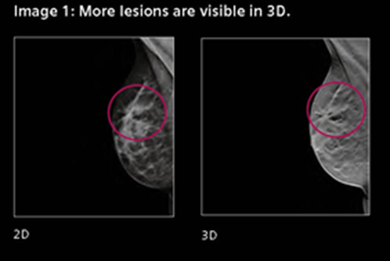
Unlike 2D mammography, 3D wide-angle breast tomosynthesis takes many x-ray pictures of each breast from many angles that are not available in traditional mammography. The x-ray tube moves in a 50-degree arc around the breast, taking 25 images during the exam. Those images are then sent to a computer, where they are assembled into a 3D picture of the breast. The result is a clearer image that helps health providers detect malignant tumors better than standard 2D mammography alone, with fewer recalls.

We introduced wide-angle tomosynthesis as an adjunct to 2D mammography because we want you and your family to be sure. We love its wide-angle imaging and the clarity it offers our doctors. We think it will save lives because it leaves breast cancer no place to hide.

Call today to schedule your next mammogram.
And be sure to ask about Wide-angle Breast Tomosynthesis.

{NAME OF HOSPITAL OR HEALTH CARE FACILITY}
{PHONE NUMBER OF HOSPITAL OR HEALTH CARE FACILITY}

