A More Comfortable Mammogram

[HEAD]
Not all mammography systems are alike. Meet our new difference maker.
[SUBHEAD]
A more comfortable exam has arrived at <Facility Name>

[BODY COPY]
Pain is the top reason why women skip mammograms. Our new system, MAMMOMAT Revelation, eases discomfort by personalizing compression force automatically. See how we’re making a difference with our most advanced mammography system yet.
Not all mammography systems are alike. Meet our new difference maker.

A more comfortable exam has arrived at <Facility Name>.

Pain is the top reason why women skip mammograms. Our new system, MAMMOMAT Revelation, eases discomfort by personalizing compression force automatically. See how we’re making a difference with our most advanced mammography system yet.
<URL>
<URL>

A more comfortable mammogram is here
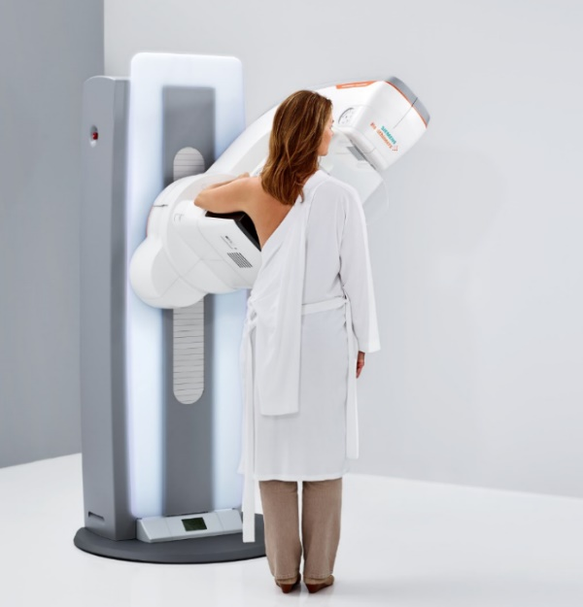

SAMPLE LAYOUT

