MAMMOMAT B.brilliant Patient Email Messaging
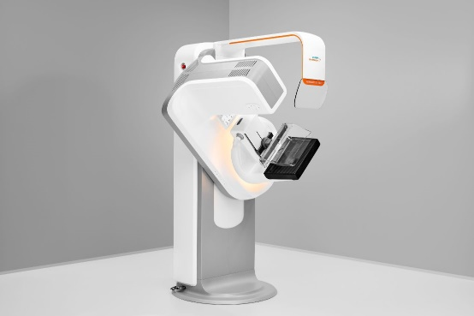
We’re now offering mammograms on the MAMMOMAT B.brilliant, the newest 3D mammography system from Siemens Healthineers. It supports high-quality images, fast exams, and comfortable experiences, so you can feel confident in your breast health care. ​
Schedule your mammogram today.

MAMMOMAT B.brilliant Webpage Messaging
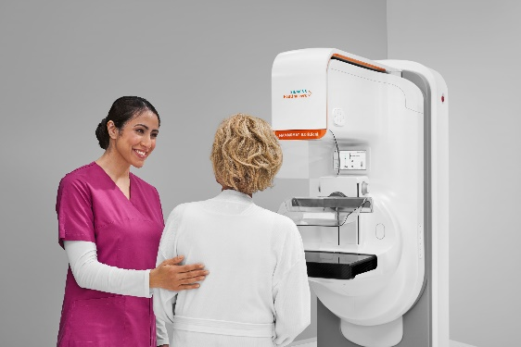
Experience the next generation of 3D mammography with the MAMMOMAT B.brilliant from Siemens Healthineers. This advanced system supports high-quality imaging while making your exam fast and comfortable. We've chosen it to provide clarity and confidence in your breast health. By combining accuracy with a low dose, it can help you feel more confident and informed about your breast health.​

